General description on U-Net tree/no-tree classification model for Agroforestry project
Shahriar S. Heydari, May 2026

Introduction:
U-Net is a very popular deep neural network model used particularly for image segmentation and classification tasks, based on a multi-layer encoder and decoder structure. The model is fed by fixed-size image patches and the encoder part creates rich and deep feature sets from it. The feature sets are then converted back to a classified/segmented image of (typically) the same size by the decoder section. Below image shows the general diagram of the U-Net model.
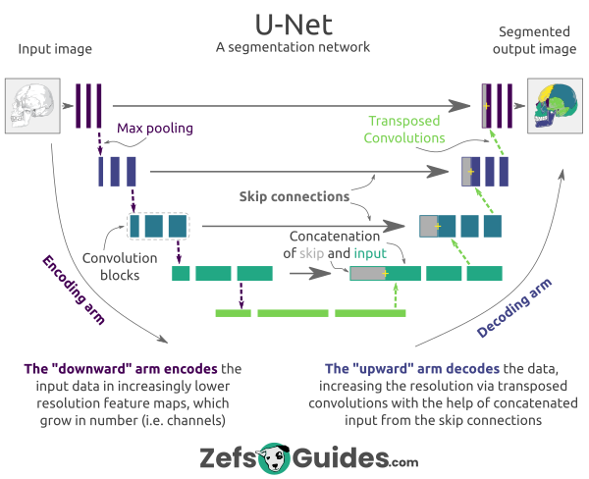

U-Net setup in Agroforestry project:
The target in agroforestry project is to assess the tree-out-of-forest (agroforestry) biomass over selected areas in the United States. To do this, we need high-resolution tree maps as the base of the work. These maps are then masked for agroforestry trees and their biomass is assessed. Creation of high resolution tree maps is done by U-Net from NAIP imagery, which has submeter resolution and is periodically available over the whole United States.
Machine-learning applications are basically done in two steps: model training (building an accurate model for prediction) and model application (creating target material from input data). We followed the same structure in this project as well.
- Model training
Our U-Net model is trained under supervised training regime. Reference data for training is supplied by CSU Geospatial Centroid as a set of bundled 4-band NAIP imagery plus its associated 1-band tree/no-tree reference map. The reference data should have been partitioned into training and testing parts, with testing part as a hold-out section not to be seen by model during training. The training part itself will be further divided into train/validation partitions, where validation part is used to optimize model for best performance through training epochs.
- Model application
Once the model is trained and reached acceptable performance, it can be fed by any compatible imagery (4-band NAIP) and will generate a predicted tree/no-tree map at the output.
- Code development platform
Model development scripting is based on TensorFlow V2 platform, a popular environment for machine learning development. It can automatically detect and utilize GPUs in addition to default use of CPU without any need for user intervention. However, once a model is trained on a GPU platform, it cannot be run for prediction without GPU access.
Each of the previous two phases (training / application) is performed through a single separate script. All of the input parameters for each script are defined at its header, no config file is used.

U-Net processing overview
Model training phase is executed through the workflow below. It requires the input data to be already split into different folders for train/val/test purpose, each folder containing pairs of NAIP + ground-truth files. These files are read and ingested into the stream of fixed-size patches. For training/validation stream, the patches can overlap and are inflated by data augmentation (creating rotated/flipped/noisy patches and add it to the training data). For test stream, data augmentation is not required, and the patches are created as non-overlapping (except for the last column/row of patches).
The training is performed in two phases: phase 1 is a fixed number of epochs and phase 2 after that fixed epochs until the model performance reaches plateau or a maximum number of epochs reached. When the run concludes, it will save the trained model as a .keras file plus a text file containing run summary info and the plot of training performance. General training workflow and output report and model performance plots for the current model (as of May 2026) are shown below.

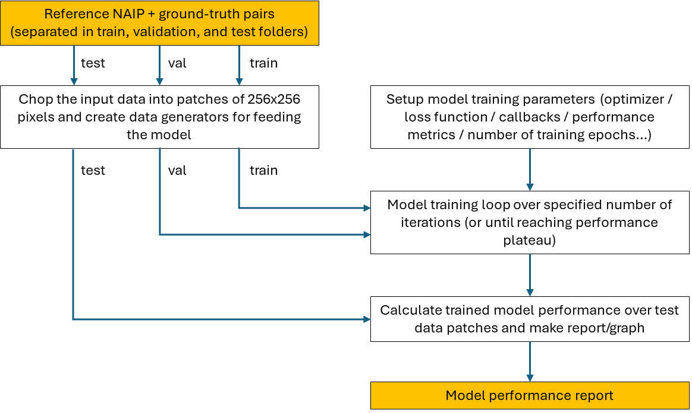
U-Net model training general workflow. Input/output blocks are highlighted orange

{
"patch_size": 256,
"stride": 64,
"foreground_threshold": 0.05,
"batch_size": 32,
"augment_flag": true,
"number of training patches": 27416,
"number of validation patches": 7102,
"optimizer": {
"name": "RMSprop",
"learning_rate": 0.0001,
"clipnorm": 1.0
},
"early_stopping": {
"min_delta": 0.01,
"patience": 10
},
"training_start": "2026-02-16T20:54:15.538837",
"training_end": "2026-02-16T21:20:22.613147",
"elapsed_time": 1567.07431,
"epochs_run": 16,
"early_stopping_point_performance": {
"accuracy": 0.970156729221344,
"f1-score": 0.7750781774520874,
"iou_score": 0.6345110535621643,
"loss": 0.31487348675727844,
"val_accuracy": 0.9780120253562927,
"val_f1-score": 0.8508219718933105,
"val_iou_score": 0.7413997054100037,
"val_loss": 0.21184059977531433
},
"global_F1_value": 0.8710071221660447,
"global_best_threshold": 0.5833333333333333,
"test_dataset_metrics": {
"accuracy": 0.9866090376735044,
"F1_value": 0.7818300029131723,
"TP": 5435987,
"TN": 218088136,
"FP": 1881792,
"FN": 1152037
}
}
Current U-Net model run report
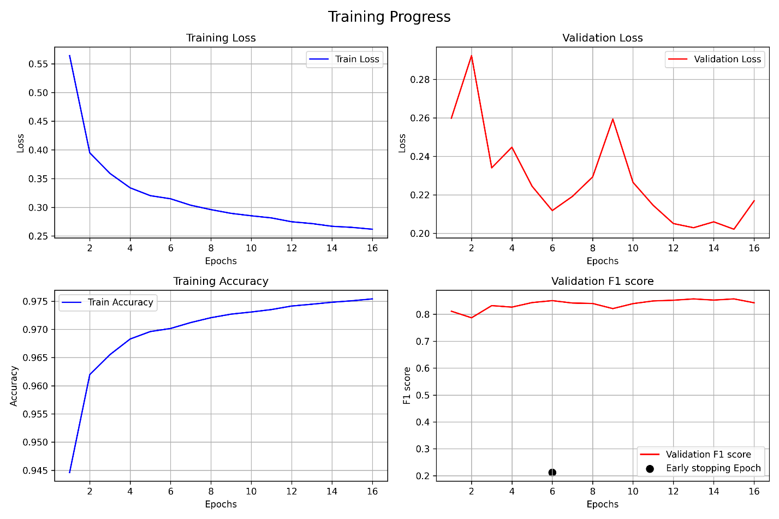
Current U-Net model training curve

Model application phase is executed through another workflow shown below. Developed script actually reads a folder and run this process for each .tif file in the given folder and save all predicted outputs in a given output folder.

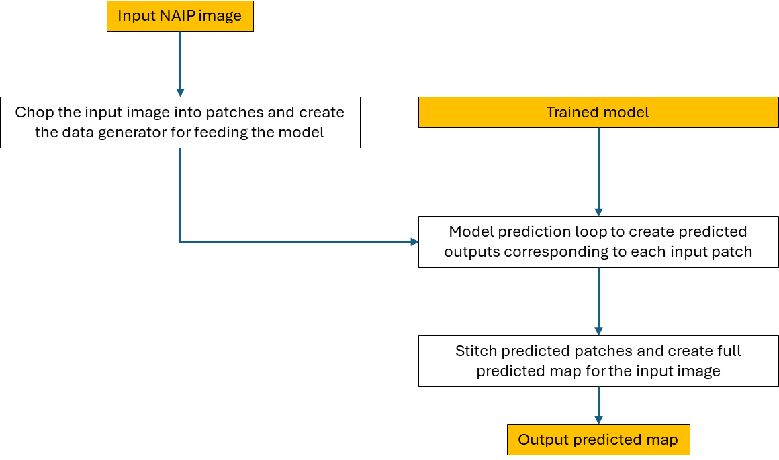
General workflow for U-Net based map generation. Input/output blocks are highlighted orange.

<END_OF_DOCUMENT>

The testing and validation label are used interchangeably by different authors and platforms. Some people use train/test and further divide train to train/validation, some other use train/validation and further divide train to train/test. We use the first naming convention in this document because it is the normal language used in TensorFlow, the platform we used to implement the U-Net model.

